Course Name | ITD 2313 – Script Programming
Instructor | Rene Hurst
Student Name | Pete Fuentez
Due date | Sep 29 by 11:59 pm
Grade | Put grade earned here
Grading Comments | Put instructor comments here

Week 5 - Scripting Projects Assignment

Project #3
Pages 84 - 85
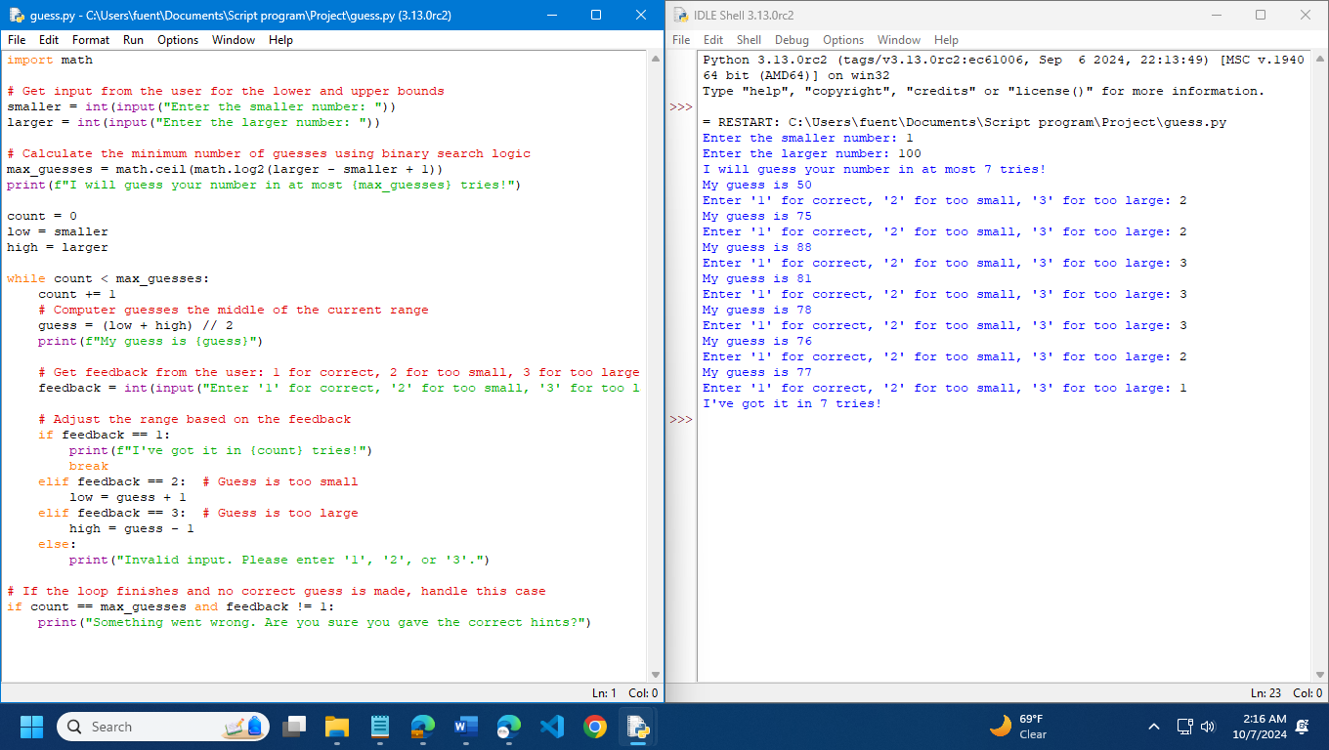

Project # 7
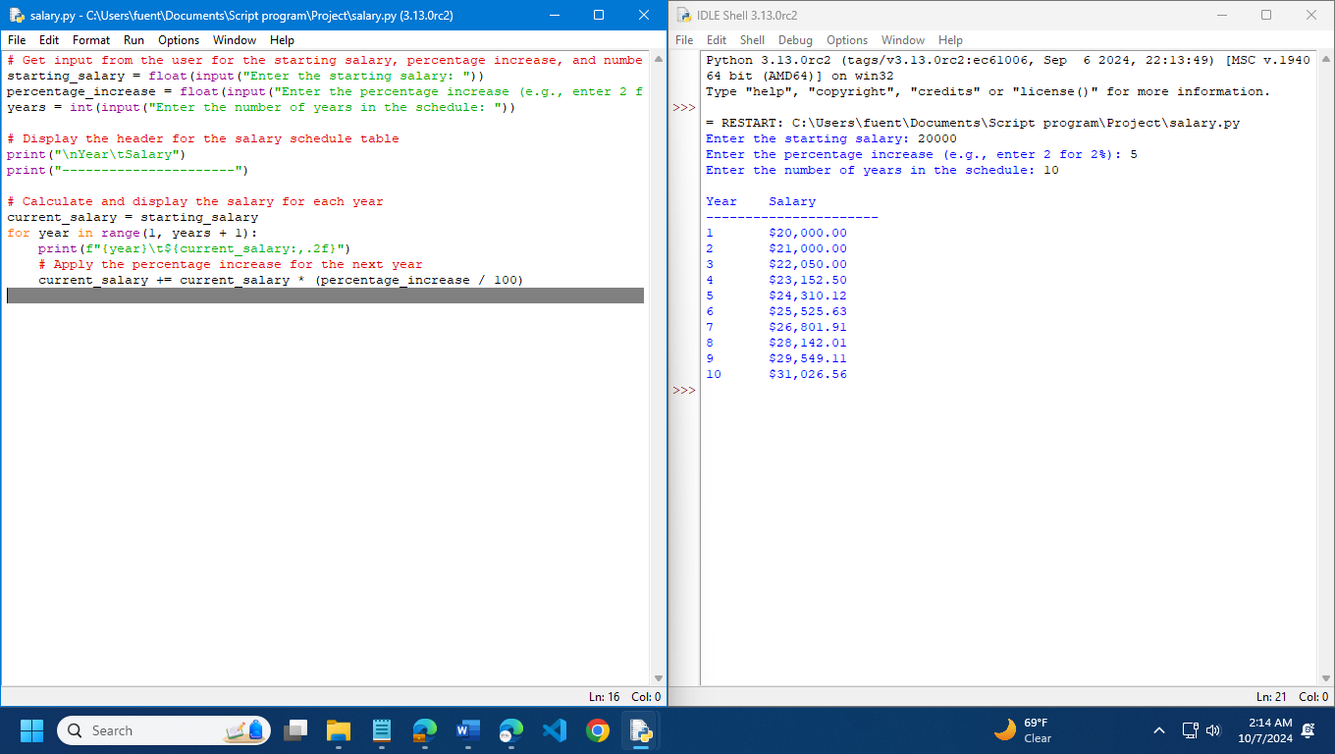
Project # 10
